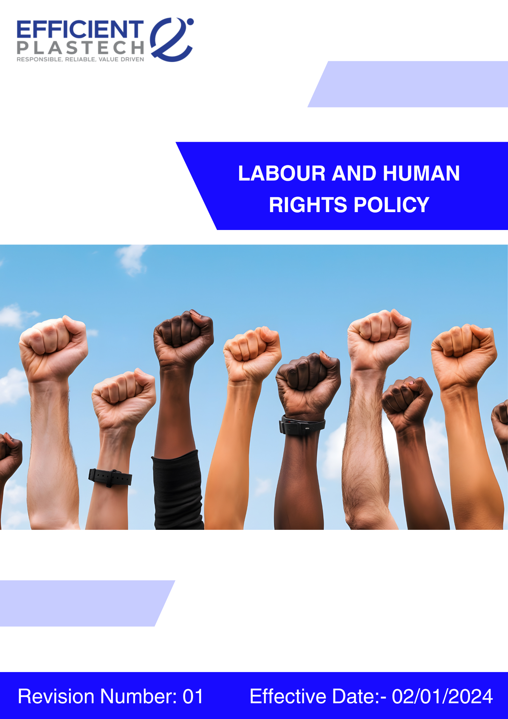
Index

❖ Introduction: 3
❖ Scope: 3
❖ Labour and Human rights Commitments: 3
❖ Quantitative Targets: 4
❖ Governance & Responsibility: 5
❖ Monitoring and Reporting: 6
❖ Communication and Transparency: 6
❖ Continuous Improvement: 6
❖ SDGs (Sustainable Development Goals) Covered in the Labour and Human rights Policy 7
❖ Review: 7
❖ Employee Acknowledgment: Labour and Human Rights Policy 8

Introduction:
Efficient Plastech Private Limited is committed to maintaining the highest standards of labour practices and human rights across all its operations. We recognize that the well-being, health, and safety of our employees, contractors, and stakeholders are fundamental to the long-term sustainability of our business. This Labour & Human Rights Policy sets out our commitment to treating every individual with dignity, fairness, and respect. Our objective is to foster a safe, inclusive, and supportive work environment that upholds human rights, promotes equity, and encourages continuous personal and professional development.

Scope:
This policy is applicable across all Efficient Plastech Private Limited facilities, employees, workers, contractors, sub-contractors, suppliers, and other stakeholders globally, including the communities in which Efficient Plastech operates. Efficient Plastech ensures that labour and human rights standards are consistently upheld across all its sites, operations, and business relationships.

Sr. No. | Address
1. | A-211, everest grande, mahakali caves road, opp. Ahura centre, andheri (e), mumbai – 400093
2 | Plot number 49, HDIL Industrial Park, Virar Ahmedabad Highway Road, Chandansar, Virar East, Ðaluka - Vasai, District - Palghar, State - Maharashtra - 401305
3 | Plot number 64, Sector 8A, Sidcul, District - Haridwar, State - Uttarakhand
4. | City Survey no. NA. 1615/A, Costal Highway, Village - Daheri Umbergaon, Taluka - Umbergaon, District - Valsad, State - Gujrat

Labour and Human rights Commitments:
Efficient Plastech Private Limited is proud to uphold and promote labour and human rights through its practices and policies.
- Employees Health and Safety: Efficient Plastech implements comprehensive health and safety management systems that include regular risk assessments, training programs, provision of appropriate personal protective equipment (PPE), and annual health check-ups for all employees. All facilities comply with local and international health and safety regulations, and potential hazards are proactively monitored and mitigated.

- Working Hours and Overtime Policy: Efficient Plastech ensures fair wages, comprehensive benefits, and reasonable working hours aligned with local laws and industry best practices. Open communication channels empower employees to voice concerns and maintain transparency regarding employment terms. Annual health check-ups are included as part of this policy to support employee well-being.

- Labour Relations: Efficient Plastech supports the rights of employees to freely associate and participate in collective bargaining. We maintain structured engagement with employee representatives to provide a platform for dialogue, collaboration, and resolution of workplace concerns.

- Career Management: Efficient Plastech invests in continuous career development through equal opportunities in recruitment, training, and leadership programs. Structured initiatives provide employees with clear pathways for growth, skill enhancement, and personal advancement.

- Child Labour, Forced Labour, and Human Trafficking: Efficient Plastech enforces a zero-tolerance policy toward child labour, forced labour, and human trafficking. We proactively audit suppliers and partners to ensure these standards are upheld throughout the supply chain. The company is committed to identifying, preventing, and addressing any risks related to human trafficking within operations and expects the same commitment from all stakeholders.

- Equal Opportunity and Non-Discrimination: Efficient Plastech fosters a workplace free of discrimination based on gender, race, religion, age, sexual orientation, or disability. We promote diversity and create an inclusive environment that empowers all individuals to thrive and contribute fully.

- External Stakeholder Human Rights: Efficient Plastech respects the human rights of local communities, customers, and business partners. We actively engage with external stakeholders to ensure our operations uphold and support their rights, while preventing any adverse impacts.

- Discrimination & Harassment Prevention: Efficient Plastech maintains a zero-tolerance approach to discrimination, harassment, and any form of abusive or intimidating behavior in the workplace. The company is committed to providing a safe, respectful, and dignified working environment for all employees, workers, contractors, and business partners.

Quantitative Targets:
The baseline year is set as 2022 for tracking Efficient Plastech Private Limited’s labour and human rights compliance and performance, with a target year of 2030.

Employees Health and Safety
- Reduce workplace incidents by 100% through enhanced safety training and continuous risk assessments.
- Achieve 100% compliance with all health and safety regulations across all facilities.
- 100% compliance with applicable occupational health and safety laws and regulations.
- 100% hazard identification and risk assessment conducted annually for all operations.
- 100% of employees and contractors trained on health and safety annually.
- 100% PPE availability and usage compliance across all work areas.
Working Conditions
- Ensure 100% all employees have access to clear, two-way communication channels regarding working conditions.
- 0 cases of forced overtime or unauthorized overtime annually.
- Overtime capped at ≤ 12 hours per week per employee, except in legally permitted circumstances.
- ≥ 95% of working-condition-related grievances resolved within 30 days.
Labour Relations
- 100% employee engagement in collective bargaining activities.
- 100% of employees have the right to freely associate or elect worker representatives.
- 100% training coverage for HR and supervisory staff on labour relations and employee engagement
- 0 unresolved collective labour disputes carried over year-on-year.
Career Management
- 100% training and development opportunities to all employees.
- 100% transparent communication of promotion criteria and career pathways.
- 70% of open positions filled through internal promotions or internal mobility initiatives.
- Minimum 20 training hours per employee per year focused on technical, safety, and leadership skills.
Child and Forced Labour
- Conduct 100% audits of all suppliers to ensure freedom from child or forced labour practices.
- 0 cases of child labour, forced labour, bonded labour, or human trafficking across operations.
- 100% age verification conducted for all employees prior to hiring.
- 100% compliance with applicable child labour and forced labour laws and ILO conventions.
Diversity, Equity & Inclusion
- Promote gender parity in leadership positions.
- 0 cases of discrimination based on gender, caste, religion, age, disability, nationality, or sexual orientation.
- 100% equal pay for equal work, with annual wage gap assessment conducted.
- 100% merit-based recruitment and promotion, supported by documented, unbiased processes.
- 100% employees trained annually on DEI, anti-discrimination, and inclusive workplace practices.
External Stakeholder Human Rights
- Engage in external stakeholder human rights initiatives regularly.
- 100% compliance with applicable human rights laws and regulations affecting external stakeholders
- 100% of high-risk suppliers and contractors assessed for human rights compliance annually.
- 100% availability of accessible grievance mechanisms for communities and external stakeholders.

Harassment & Discrimination
- 0 tolerance for harassment or discrimination of any form at the workplace.
- 0 substantiated cases of harassment or discrimination annually.
- 100% of employees and contract workers covered under anti-harassment and anti-discrimination policies.
- 100% annual training coverage on harassment prevention and respectful workplace behavior.
- ≥ 95% of complaints investigated and closed within 30 days.
- 0 retaliation cases against complainants or witnesses.
- 100% confidentiality maintained in handling complaints and investigations.

Governance & Responsibility:
- Board of Directors: Policy approval and oversight.
- Top Management: Provide resources, ensure implementation, and review policy compliance.
- HR Department: Policy administration, and review of Policy, records, grievance handling, monitoring, training.
- Department Heads/Managers: Ensure compliance at team level, approve leave, address grievances.
- Committees:
  - Health & Safety Committee – monitor safety practices.
  - Grievance Redressal Committee (GRC) – resolve disputes.
  - Internal Complaints Committee (ICC) – address harassment cases.
  - Audit Committee – oversee whistle-blowing disclosures.
- Employees: Comply with policy, report concerns, and support safe and respectful workplaces.

Monitoring and Reporting:
- Employee Feedback Surveys: Regular surveys are conducted to assess employee satisfaction with working conditions, safety, and career development.
- Risk Assessment: Regular Risk assessment are conducted to assess employee with working conditions, safety, and career development, Discrimination and Harrassment

Communication and Transparency:
- Labour & Human Rights Policy is publicly accessible and communicated internally to ensure all employees and stakeholders are informed.
- Employees and external stakeholders are encouraged to report any violations or concerns through confidential reporting channels without fear of retaliation.

Continuous Improvement:
Efficient Plastech Private Limited is committed to ensuring the continued accuracy, relevance, and transparency of its Labour & Human Rights Policy and reporting practices. To achieve this:
- Annual Review Protocol: The policy and associated reports will be reviewed annually by a cross-functional team, incorporating inputs from employees, management, and external stakeholders.
- Benchmarking: Efficient Plastech will continuously assess its practices against evolving global labour and human rights standards, including UN SDGs, ILO conventions, and recognized industry guidelines.
- Audit Integration: All practices and KPIs will be evaluated through internal assessments and third-party audits to ensure compliance and effectiveness.
- Feedback Loops: Employee and stakeholder feedback will be actively solicited and used to identify opportunities for improvement.
- Stakeholder Dialogue: Efficient Plastech will engage in ongoing dialogue with communities, clients, suppliers, and other key stakeholders to foster shared responsibility in upholding labour and human rights.
- Commitment to Zero Incidents: The company aims to maintain zero incidents related to workplace discrimination, harassment, and safety violations.

SDGs (Sustainable Development Goals) Covered in the Labour and Human rights Policy





Review:
The Labour & Human Rights Policy will be reviewed annually by the Human Resources Manager for its effectiveness, and relevance. This review will ensure that the policy adapts to changing regulations, stakeholder feedback, and evolving company goals. Updates and changes will be communicated to all employees and stakeholders as necessary.

Approved By:

Designation:

Last Review Date: 01/09/2025
Next Review Date: 01/09/2026

Employee Acknowledgment: Labour and Human Rights Policy
I acknowledge that I have received, read, and understood the Labour & Human Rights Policy of Efficient Plastech Private Limited. I am aware of the company’s commitment to upholding labour and human rights, ensuring a safe and inclusive work environment, and promoting the health and well-being of all employees.

I understand my responsibilities in supporting this policy, including complying with all applicable labour laws, engaging in open communication regarding working conditions, and participating in initiatives that promote diversity, equity, and inclusion. I agree to adhere to fair labour practices in my daily work, report any violations or concerns, and contribute ideas for continuous improvement.

By signing below, I confirm my commitment to upholding the Labour & Human Rights Policy and supporting Efficient Plastech Private Limited’s efforts toward creating a positive and equitable workplace for all.

Employee Name:

Employee Signature:

Date:

